2023 Taos Studio Tour
Artists’ Guidelines

The 16th annual Taos Studio Tour (TST) will take place Labor Day Weekend Saturday, September 2 - Monday, September 4, 2023

Application:
Please read the full Artists’ Guidelines before filling out the TST application form.

- To be eligible for the tour, artists must either live in Taos County AND/OR have their own studio located within TAO tour map.
- To retain the integrity of the tour, artist must sell only their own original items and editions. Nothing created using commercially available kits is permitted.
- Artists may share a studio location. Each artist in the studio location must submit their individual membership application, membership fee, tour application and tour fee.
- Artists with their own gallery must only show their work.
- Artists must commit to a studio location at time of application.
- Artists MUST be open all three tour days (Saturday through Monday) from 10 AM – 5 PM. Your commitment to honor these hours benefits all participating artists and the public that attends and supports the TST.
- Artists are responsible for collecting and reporting the applicable gross receipts tax in the aggregate (calculate a total). You must register your business with the county, forms provided to complete can be found at: https://www.taoscounty.org/430/Business-Licenses. (Subject to change)
- Artists are required to volunteer for at least one of the TST Teams and perform the tasks that help us create a successful tour OR pay the full tour fee to opt out of volunteer hours on a Tour Team. See TST Team description document and Team Selection form attached.
- Tour cancellation - In the event the TST must be cancelled, the TST Board will endeavor to refund as much of the tour fee as fiscally possible to each artist. This could be very last minute due to changes in Covid-19 mandated requirements or other mitigating circumstances.
- Artists are required to sign the Hold Harmless Agreement (attached) and return it with their completed application.
- Artists should attend TAO monthly membership meetings via phone or computer during the months of May, June, and July, pick up flags and brochures in August and return flags in September ($50 fee for non-return flags).

TST Payment Information
Membership Dues:
- Artist(s) must have paid TAO dues for current year ($60).
- Dual Household ($100, 2 artists in household, shared studio)
- Student ($30)

Studio Tour Fee:
- $175 per artist if volunteering on tour team (we prefer you to volunteer)
- $475 per artist if electing to NOT volunteer on a tour team – must still assist with brochure and poster distribution
Note: Make a check(s) payable to: Taos Artist Organization Mail to: TAO – PO Box 1294, Taos, NM 87571 (TAO) OR Use PayPal on TAO website.

Images
Artist must provide:
- One 6” x 4” (landscape) high res (300dpi-dots per inch) image for brochure
- Email image to David Douglas at david@shutteringexperiences.com
- Deadline: April 30, 2023. If you choose to reuse the 2022 image, please contact David Douglas at david@shutteringexperiences.com
- Accepted artists(s) who do not provide the correct image will have the TST logo image displayed in the brochure.
- Participants and sponsors appear on the TAO website for a year with links to their websites.
- Optional: Publicity image (4” x 6” hi res, 600dpi)
- For questions concerning images, contact: David Douglas at david@shutteringexperiences.com
- For questions concerning images on the TAO website: Contact David at david@shutteringexperiences.com or call (505) 263-4011.

Tips for Artists:
- If Artists choose to offer simple refreshments, please label food and drinks to avoid allergic reactions. If Covid-19 is still an issue, offer pre-packaged crackers, cookies. Offer bottled water.
- Artists are encouraged to remove or highlight any tripping hazards on their property and/or in their studios.
- Artists need to carry appropriate insurance.
- Artists are strongly encouraged to clearly mark parking areas to help with flow of traffic and to avoid blocking driveway. Keep in mind the possibility of emergency vehicles needing access.
- As a participating artist, you are receiving a large amount of advertising for your participation fee. Please expand TAO's marketing efforts by sending personal invitations/or notices to your collectors/mailing lists and social media outlets, Like our Facebook page, Instagram, comment and share with family/friends.
- If Covid cases are up, you may find guidance on Covid at https://cv.nmhealth.org.

Page 1

ARTIST APPLICATION FOR TST 2023 (Pages 1 – 5)

2023 Information Required for TAO Brochure/Map:
- One 6” x 4” high res (300dpi-dots per inch) image for brochure emailed to David Douglas at david@shutteringexperiences.com
- Mark your location on the Map and complete all fields on the form.
- Send your completed form & check to: TAO, PO Box 1294, Taos, NM 87571 by April 30th, 2023.
- Sign and date application

TOUR PRICING (Two choices, select one):
Because some people are unable to do the traditionally required volunteer tour teams as part of the tour's discounted pricing, we offer two pricing options for participation:
TOUR - One Artist: $175.00*
I agree to volunteer on one or more of the TAO Studio Tour Teams outlined in the attached documentation.

TOUR - NOT VOLUNTEERING – One Artist: $475.00*
Unfortunately, my schedule makes it impossible for me to volunteer for a tour team so I will pay the higher fee.

*Note: All artists help in the distribution of brochures and posters.

INFORMATION FOR BROCHURE AND WEBSITE

Name or Business____________________________________________________

Your Name__________________________________________________________

Medium(s)_____________________________________________________________

Studio Address_______________________________________________________

Home Address________________________________________________________

Phone Numbers_______________________________________________________

Email_______________________________________________________________

Website______________________________________________________________

Page 2

Studio Tour Teams – Select a Team(s)
Please read 2023 Studio Tour Team Descriptions prior to making your selection(s). Be sure to mark a second choice in case your first choice is taken. Note, if your non-studio tour partner has skills that would benefit a team, their work on a team would substitute for you!
First choice – must select one:
Design___(needs one more)filled
Promotion*___(needs ten people)
Ad Negotiator_______(NEW POSITION, needs one person)
Preview**___(needs six people)
Sponsorship___(Lynn F. and Bill Baron; needs one more person)
Distribution - Brochures___ (needs four people)
Distribution – Flags and signs ____(needs three people)
Tour Point Person___(one person)Filled
Second choice – select one:
Design___ filled
Promotion*___
Ad Negotiator____(NEW POSITION, needs one person)
Preview**___
Sponsorship___
Distribution - Brochures___
Distribution – Flags and signs____
Tour Point Person___Filled

*Requires basic computer skills and internet access, e.g., type and send an email, Google for email addresses.

**One volunteer needs computer and software skills (word processing and graphics)

Page 3
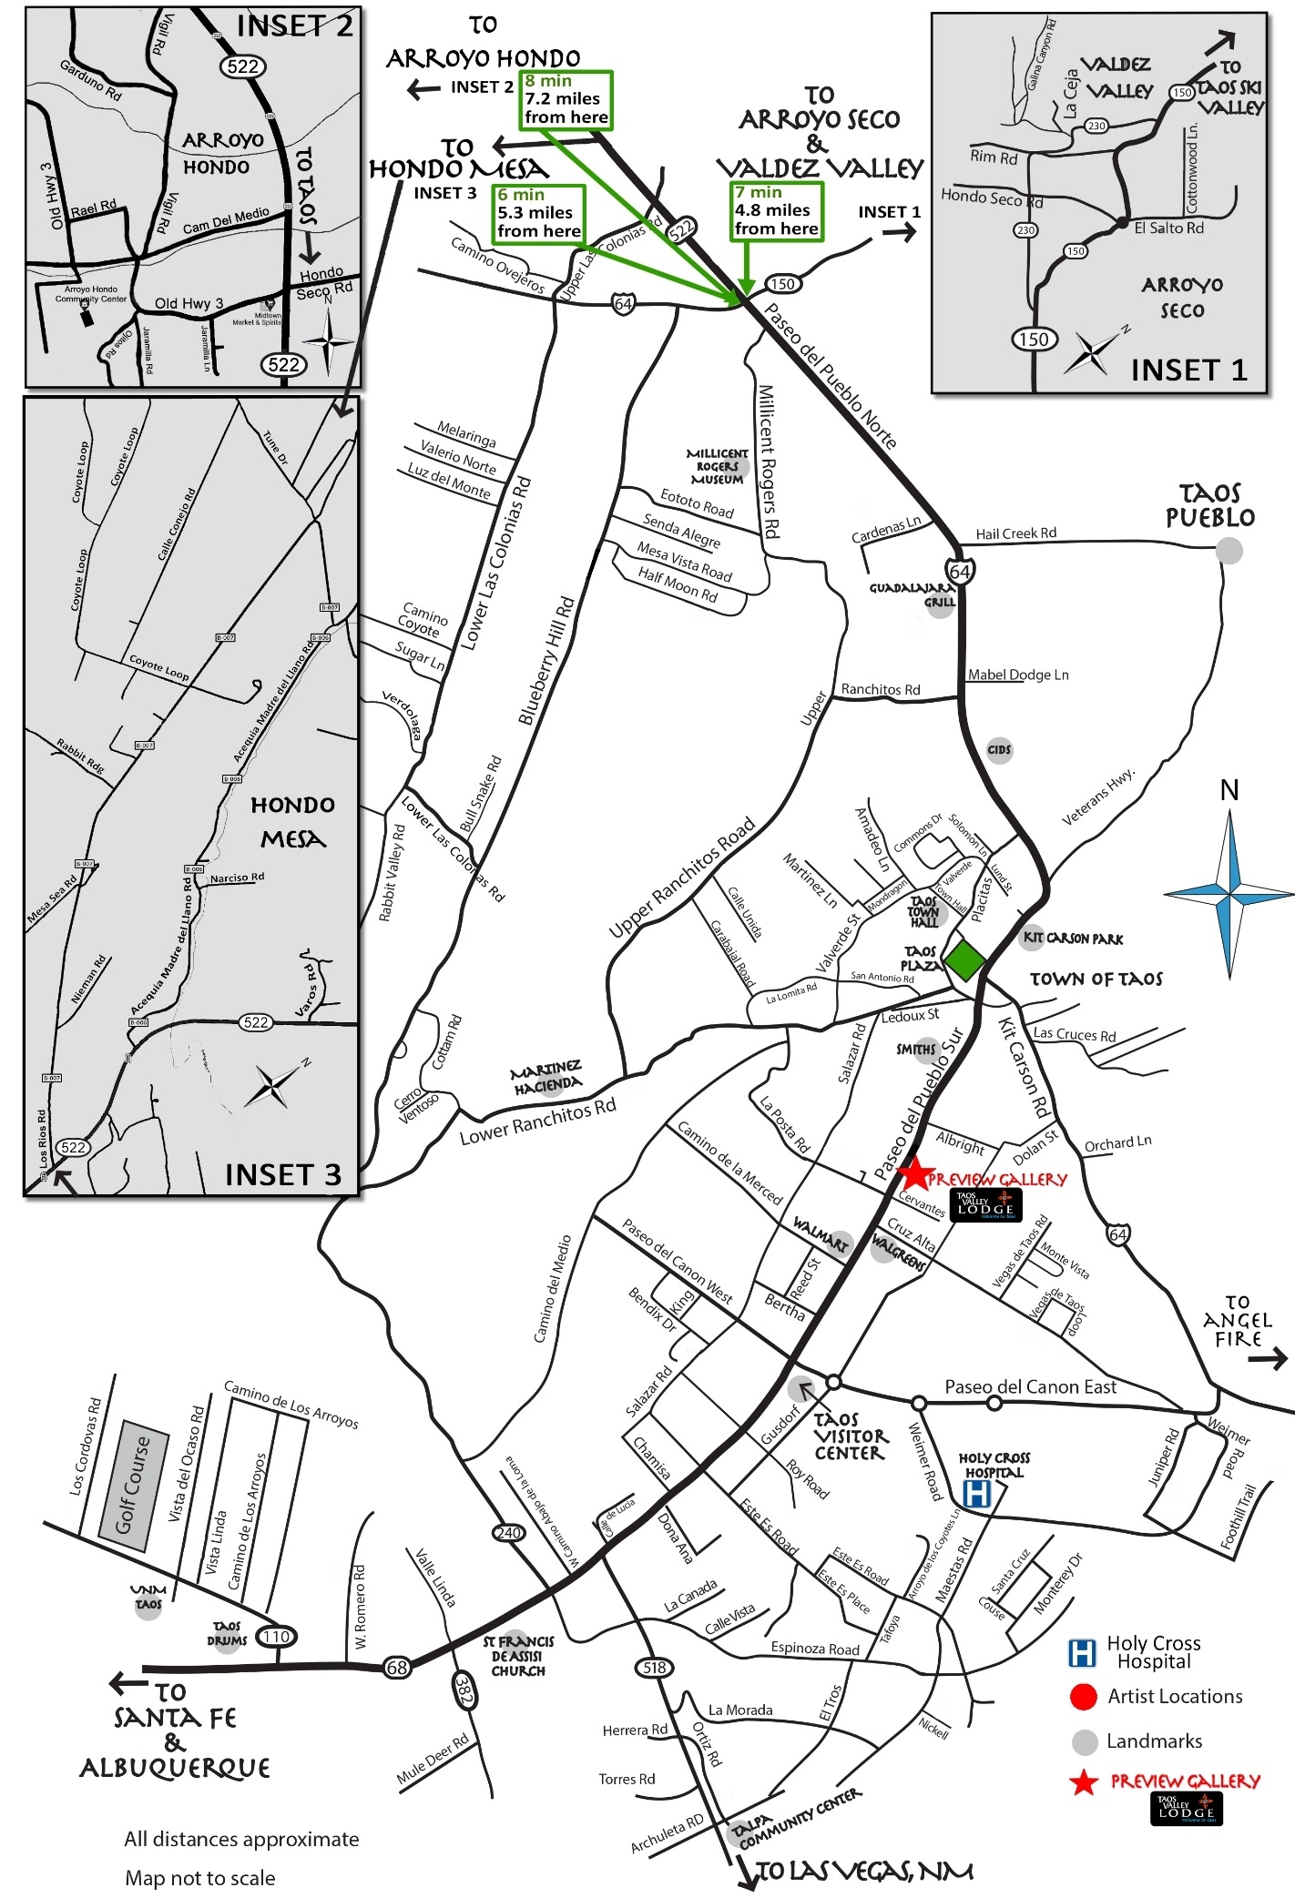
Page 4
By signing this application:
- I agree to abide by the Artists’ Guidelines;
- I agree that I have read and will follow the Application Checklist;
- I will provide TAO with my gross tour receipts* and the number of visitors by city and state. If I fail to provide this information, I forfeit my ability to participate in the Taos Studio Tour the following year; *Used in aggregate for grant applications.
- I agree that I want to increase my sales so will provide one piece of art for the Taos Studio tour (TST) Preview Show and Gallery.
Note: If your piece sells, you have the option to bring in a new piece.
- I will promote the TST through mediums I have available; websites, social media, mailing lists etc.;
- I agree that the articles I offer for sale are made by my own hand, are designed by me, and are like those represented by the images provided in my application;
- I understand that I retain full ownership and copyright, but the TST may use the images and promotional information that I have submitted in this application for all promotional purposes without notice or payment to me;
- I will be responsible for my own insurance, liabilities, sales tax and costs incurred for my studio location; and
- I acknowledge that even if I paid to be a Non-Volunteer, I understand that I am still required to help in the distribution of brochures and posters.

Printed Name: ______________________Signature: _________________________Date: _________
Artist application must be postmarked by May 1, 2023.

Page 5
Hold Harmless Agreement

THIS AGREEMENT is made the ____ day of __________, 2023 by and between the Taos Studio Tour, the Taos Artist Organization (TAO) Board of Directors, its volunteers, and ____________________________, hereinafter referred to as “ARTIST.”

ARTIST agrees as follows:

Hold Harmless:
ARTIST agrees to indemnify and hold harmless the Taos Studio Tour, the Taos Artist Organization (TAO) Board of Directors, and Its Volunteers, from all claims, losses, suits, damages, judgments, expenses, costs and charges of every kind, including court costs and attorney’s fees, resulting from ARTIST’s participation in the 2023 Taos Studio Tour by reason of personal injuries, death, or property damages.

ARTIST further agrees to indemnify and hold harmless the Taos Studio Tour, the Taos Artist Organization (TAO) Board of Directors, and Its Volunteers from any claims and for all damages, costs, and expenses, including, without limitation, court costs and attorney’s fees and amounts paid in settlement incurred in connection with such claims arising out of acts of negligence of ARTIST, his agents, or his employees.

Artists must agree to follow all current State Health Guidelines.

Loss & damage:
ARTIST releases the Taos Studio Tour, the Taos Artist Organization (TAO) Board of Directors and Its Volunteers of any liability for illness, loss, theft, vandalism, fire or other damage to ARTIST’s property which may occur during the 2023 Taos Studio Tour, whether resulting from fire, storms, public health orders, acts of God, theft, pilferage or other causes.

Print Artist Name: ____________________________________________________________________

Artist’s Signature: _____________________________________________________________________

Date: _______________________________

2023 STUDIO TOUR TEAM DESCRIPTIONS
Teams meet outside of the general meeting time and use the monthly meeting to report back to the TAO membership.

DESIGN Lead: David Douglas (Lydia Johnston – proofer and deals with getting corrections made with marketing vendors)
• Creates Map and Brochure and gets them printed as well as delivered to
Taos News
• Creates Gallery Guide ads series; works with fellow member-proofer for
copy accuracy
• Creates poster for distribution. Communicates with Distribution – Brochures Lead to
obtain posters for distribution
• Works with Treasurer to get lists of participating members
• Works with Sponsorships to get sponsor lists and logos
• Works with Website Administrator to get website updated for Studio Tour
• Updates the group at the monthly meetings
This team uses a proofer & detail-oriented person to receive tour applications as they come in and convert them into a digital format (create digital lists from handwritten info that can be handed off to the designer)

Ad Negotiator: Lead: TBD (One person) – The person applying for this role should have negotiating experience for ads. This position will negotiate rates with all vendors utilized for the studio tour, e.g., Taos News, Billboard, Radio, etc. In addition, this person will work with Teams to make sure copy is submitted by deadline.

PROMOTION: Lead: TBD (Ten other people*)
• Brainstorms and develops new ideas about widening our reach/audience
• Plans radio blasts and interviews with local radio stations
• Blast email from TAO Gmail list on Google. Should be done two weeks
before tour starts
• Digital calendar entry, e.g., KUNM
• Connects with media outlets who write about the local arts/tours
• Creates PR copy about the tour (or organizes getting that done by a paid
professional)
• One team member attends monthly City of Taos marketing meetings (Lodger’s Tax
Advisory Committee)
• Team brainstorms and provides Taos News PR person the content that she can
promote
• Comes up with creative/out of box methods for broader outreach
• Connects with Texas and Colorado tourist organizations
• Updates Social Media accounts—assigns one to two team members to be in charge of
social media for the group
• Updates the group at the monthly meetings

WEBSITE/DIGITAL TASKS: Lead and Web Master: Jake Atensio
• Keeps the website updated and fresh
• Plans website expansion and works over the course of time to implement
those plans and expand the website’s offering to members--member
pages, download areas
• Creating an app for the tour?
• Make sure the email list reflects the current TAO membership so that all
current members get the monthly emails about the meetings and old
members do not
• Updates the group at the monthly meetings

PREVIEW SHOW AND PARTY: Lead: Susan Gancher (Six other people**)
• Secures professional, light filled venue to serve as our exhibition space
early in the year
• Plans opening party and schedules any artist demos/talks etc.; connects
with promotions to promote
• Secures a professional art seller to work at the exhibition for the long
weekend of the tour
• Organizes and communicates with group about when/where to drop of
work
• Hangs the show; plans and communicates artwork pick up post-tour
• Takes photos of opening and shares these with website point person in
timely manner
• Updates larger group at the monthly meetings
If you have event planning experience, experience hanging shows, or just a willingness to help, this could be a good fit

SPONSORSHIP: Chair: Lynn Fitzgerald (Needs two more people)
• Approaches local businesses about sponsoring the tour
• Receives payments and delivers to treasurer
• Provides Design team and social media point person with logos and list of
participating sponsors
• Invites sponsors to opening party
• Brainstorms any VIP experience or bonus we can offer them
• Writes thank you notes afterward
• Updates larger group at the monthly meetings

DISTRIBUTION - Brochures: Chair: TBD (needs three more people)
• One team member picks up brochures/maps and posters at printer
• Team creates packets for individual tour members to pick up at July
monthly meeting
• Revise sign-up list from last year of locations to place the brochures that
all tour artists share in distributing (Make a note: Don’t forget to give to family and
friends!)
• Farmers’ Market presence the two Saturdays before studio tour
• Works with the Sponsorship committee to get them posters to give to
Sponsors to hang in their businesses
• Gets tour artists to hang posters on all local bulletin boards – make a list
of businesses
• Works with the Promotion Team to get the posters to any outlets in the
broader region with whom they have connected
• Determines who will keep extra brochures for artists to pick up
• Updates the group at the monthly meeting

(*Note: All tour artists are required to distribute brochures.)

Distribution – Flags and Signs Lead: TBD (Needs two more persons)
• Distribute and plan the return of the banners/flags for the individual
studios (complete sign out and sign in sheet, flag/sign condition); Located at Alice’s
Attic Storage; Lead will obtain password from previous Lead
• Make sure sandwich board sign is delivered to Show/Gallery location (2023-Taos Valley
Lodge)
• Contact (Judy Escobel @ 575-737-2627 OR Valorie Mondragon @ 575-737-2617) to
get permission to place banner on Kit Carson Park fence at lighted intersection to Taos
Community Auditorium
• Updates the group at monthly meetings

TOUR POINT PERSON: Erica Wendel-Oglesby
• This person answers questions/emails/issues regarding the tour and
forwards to different team leaders as necessary or relevant
• Connects with leaders of each team before the beginning of the year
outside of the monthly meeting to confirm their participation
• Troubleshoots any issues as needed
• Reaches out to membership about who might lead the various teams that
year

*****
GRANTWRITING: XXX(grant application completion)
• Search out potential grant funding for the group
• Write grants/Meet deadlines
• Follow up on grant status

*Requires basic computer skills and internet access, e.g., type and send an email, Google for email addresses.

**One volunteer needs computer and software skills (word processing and graphics)

